Brian Engel

Module 4 Activity Exceptions

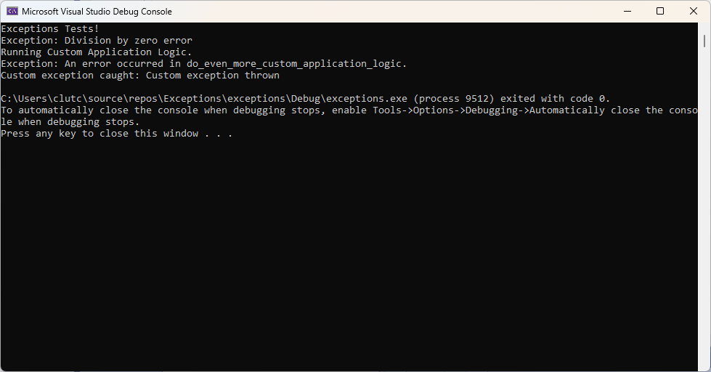

This activity is pretty straight forward and the process I used was to just follow the TODO’s in the started code. I don’t think I’ve ever created a custom exception before and if I have its been a while so that was the only real road bump I ran into, but it didn’t take long to figure it out. I guess I’ve also never really used catch(...) for unexpected exceptions either, and I’m a little unsure of how you would handle an exception that you don’t see coming once you catch it. It seems that it should have been handled further up the line. Other than those two things it was mainly adding try / catch blocks and throwing errors in certain situations.